Hibernate Notes

Hibernate.cfg.XML

* This needs to be saved at root, class path so that hibernate can use it.
* This file contains details to get connected to database through JDBC.

XML Configurations to map Objects to database tables is legacy.

Annotation configurations

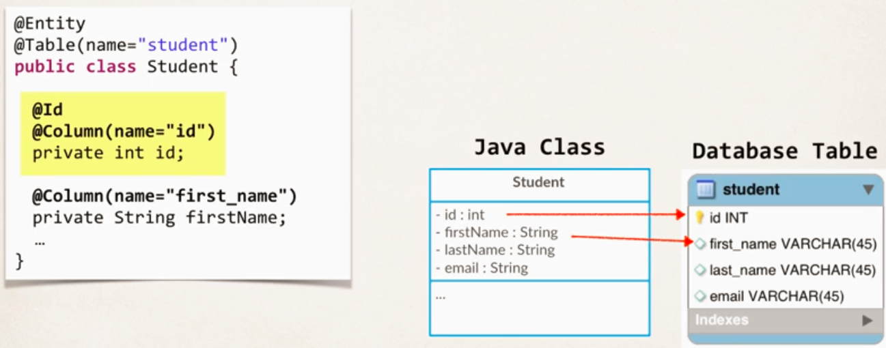

* Don’t use ID filed in Constructors.

Saving Objects to database

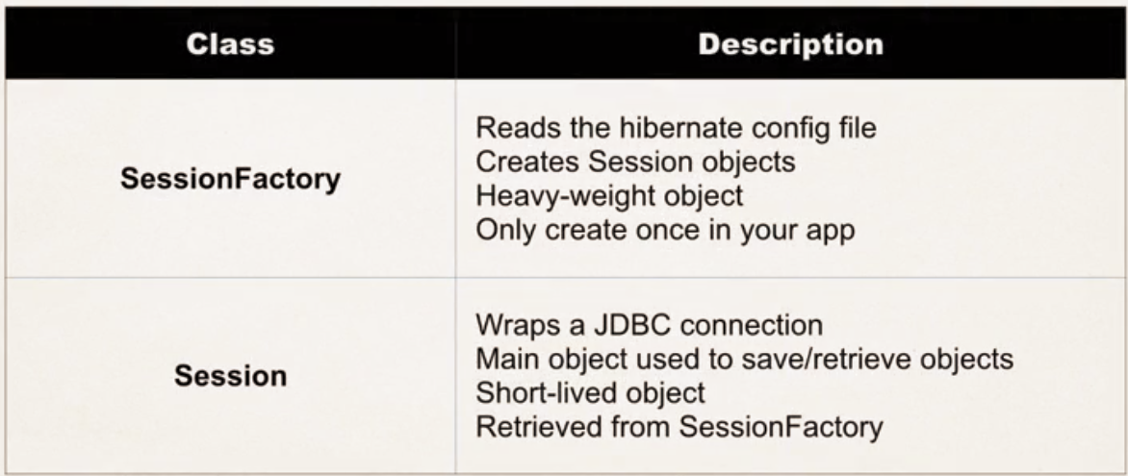

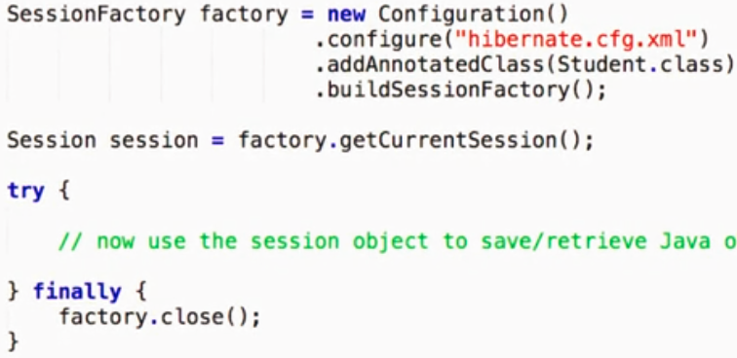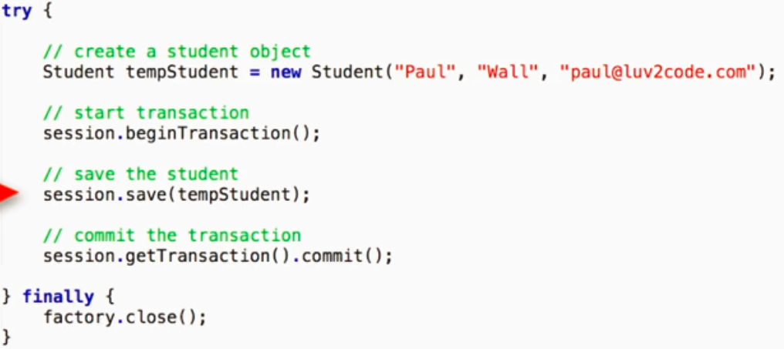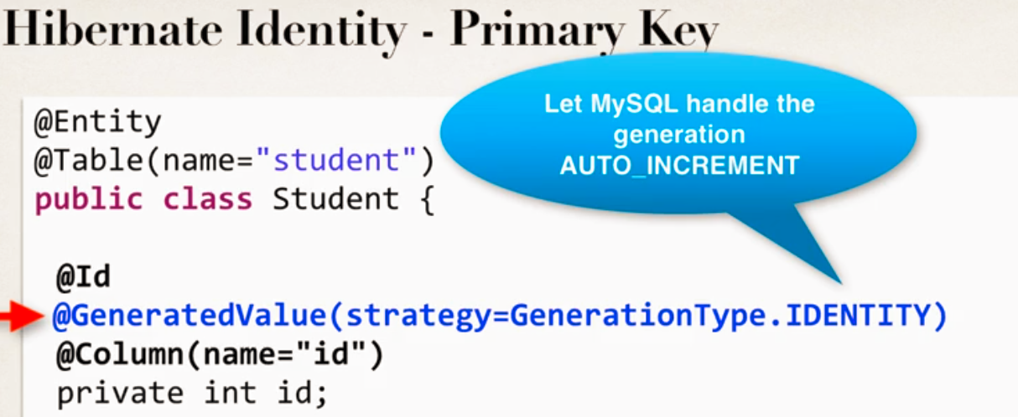

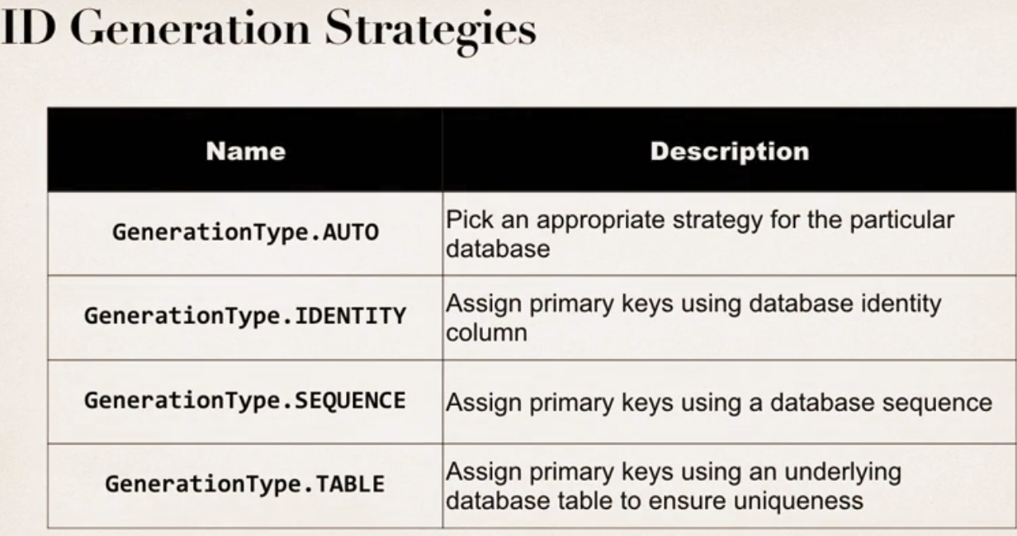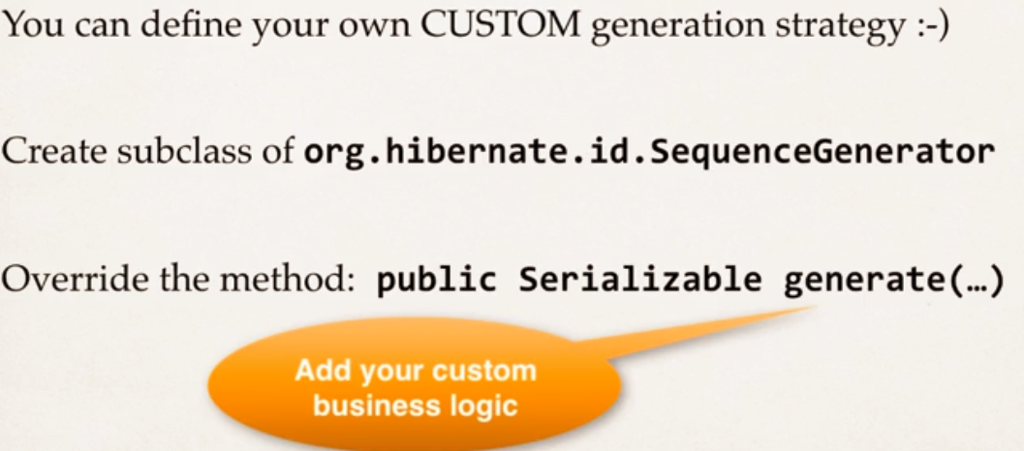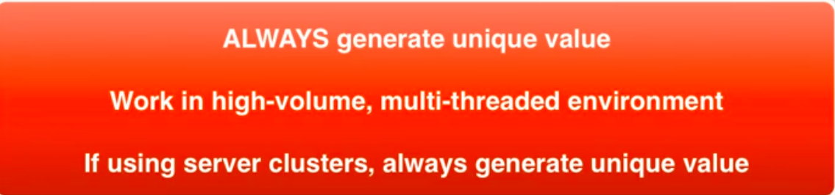



Retrieving Objects

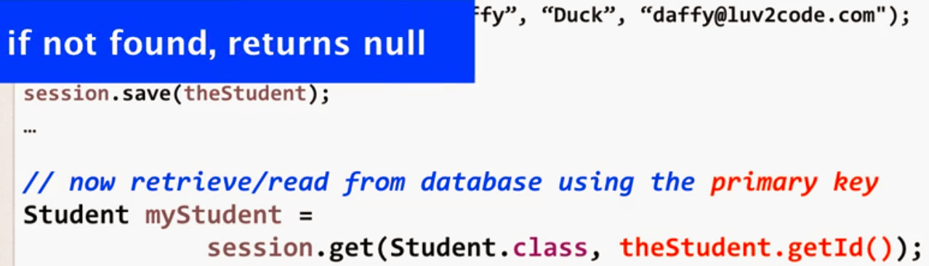

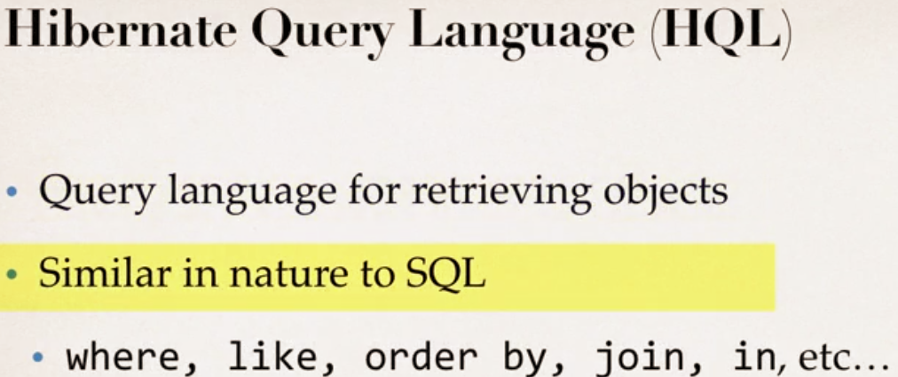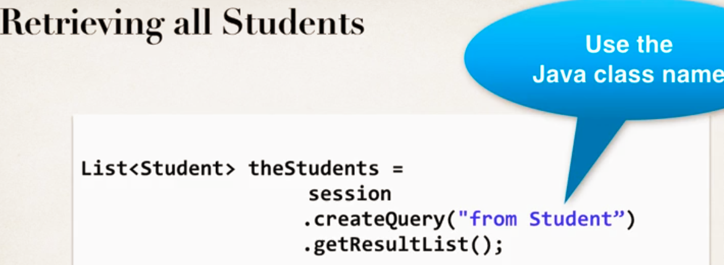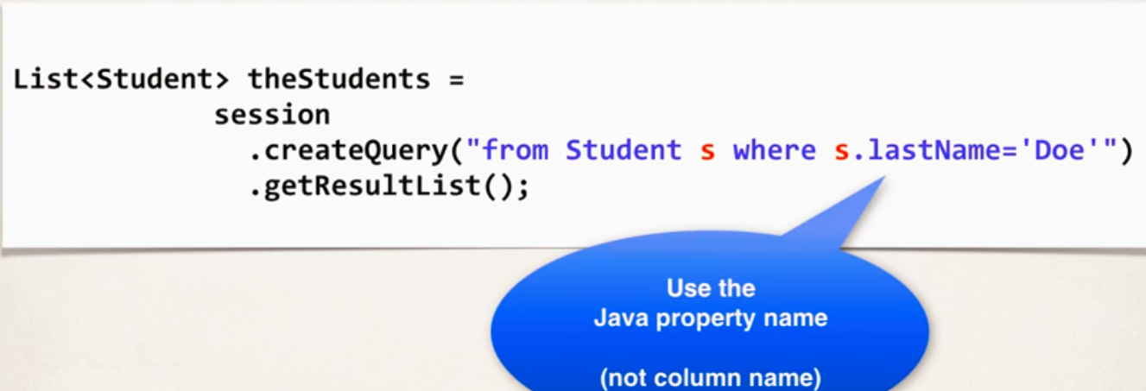

OR/Like Predicate example syntax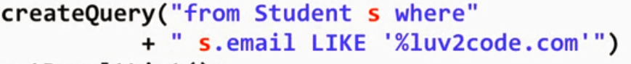

Updating objects

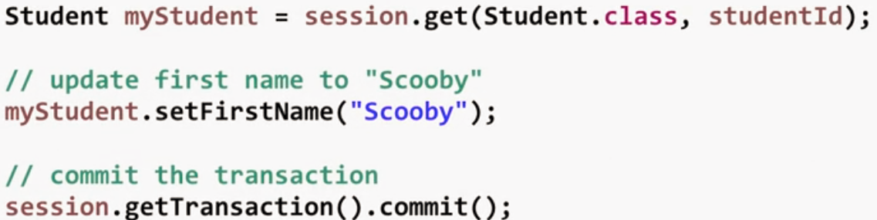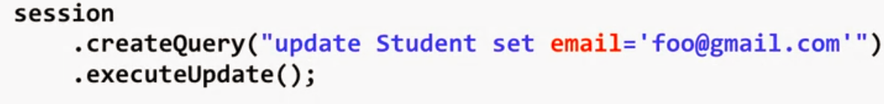Delete object

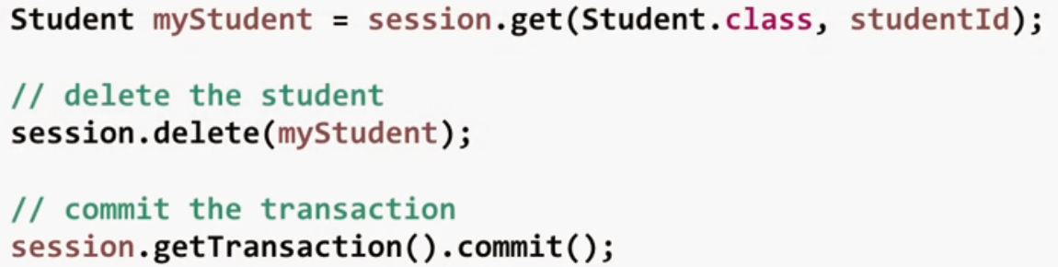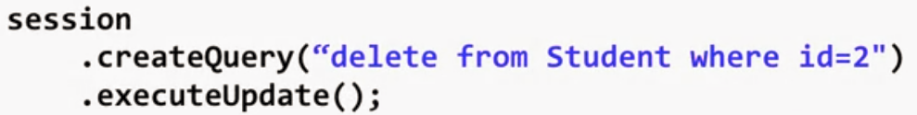

Mappings

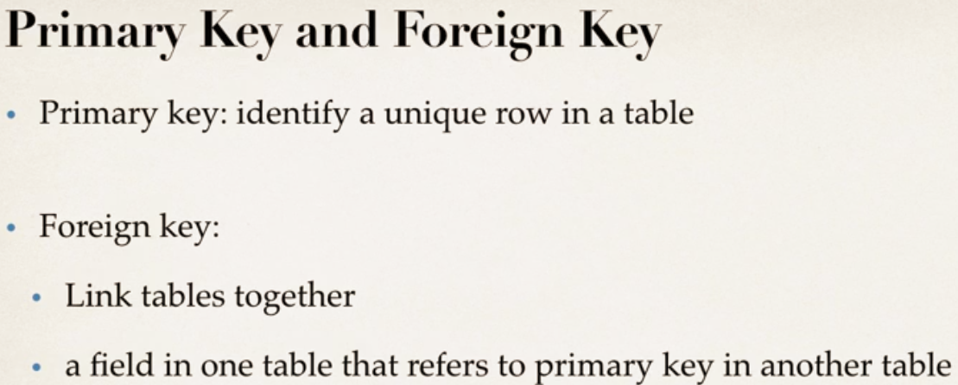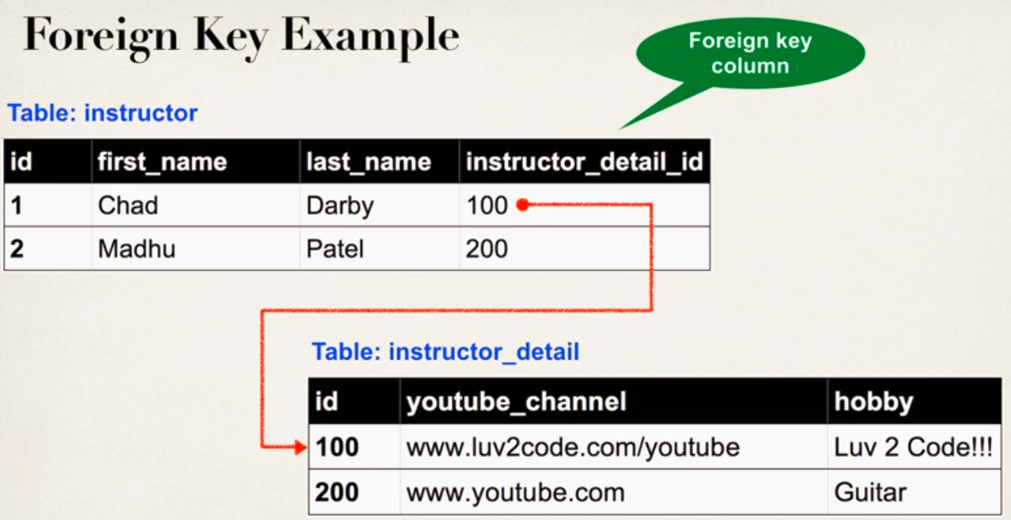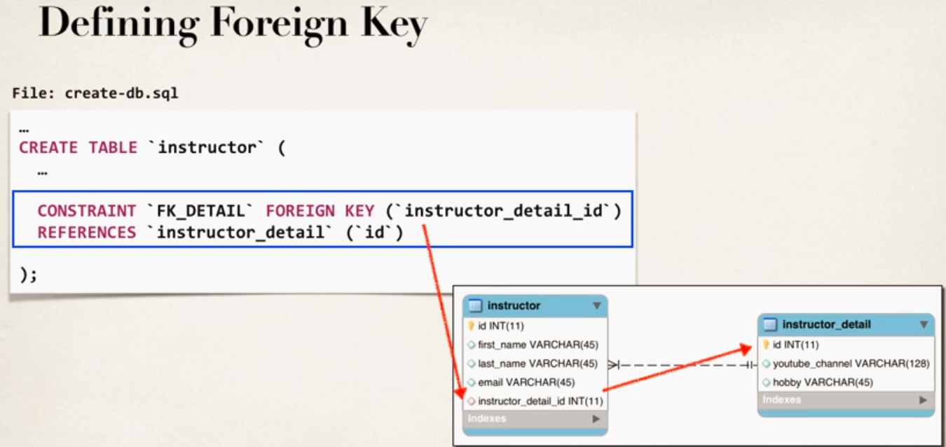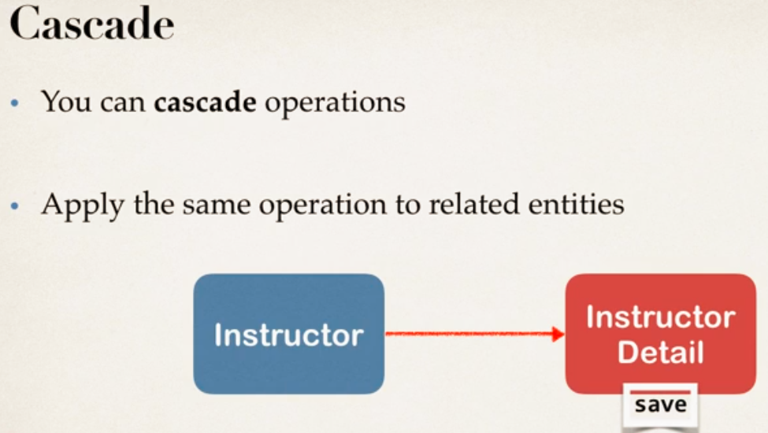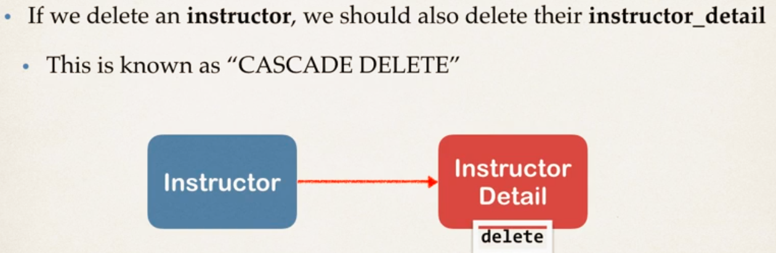

Entity Lifecycle

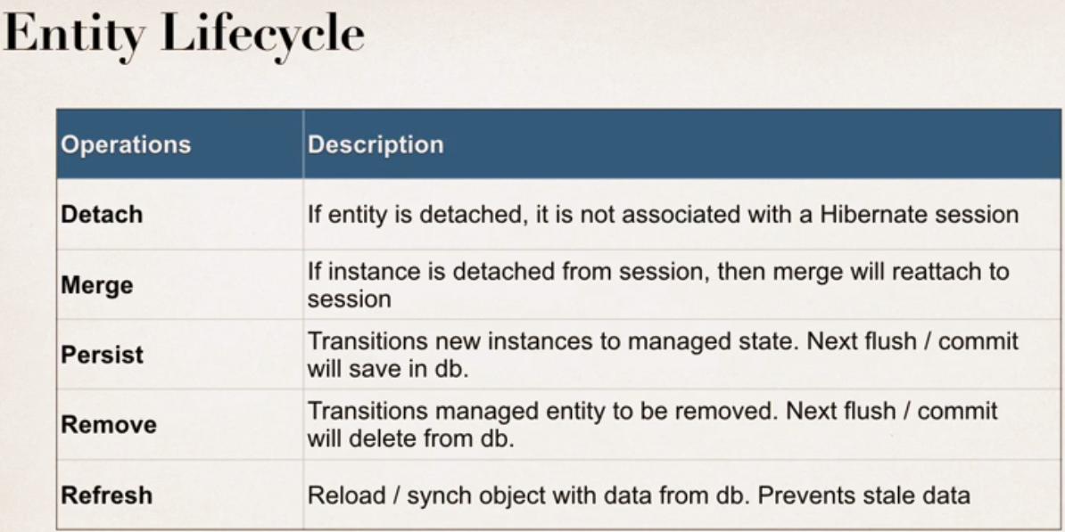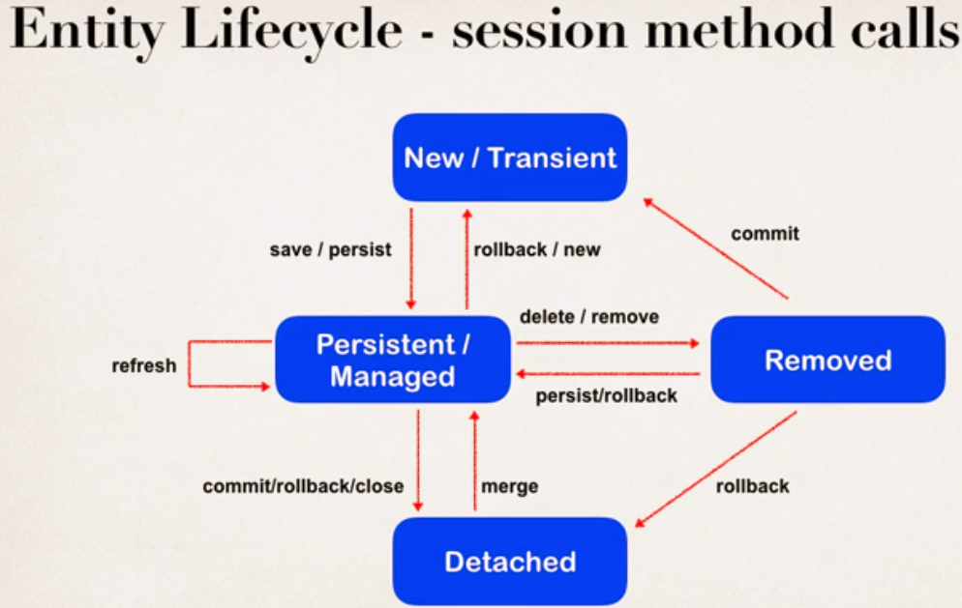

One to One mapping – Uni Directional

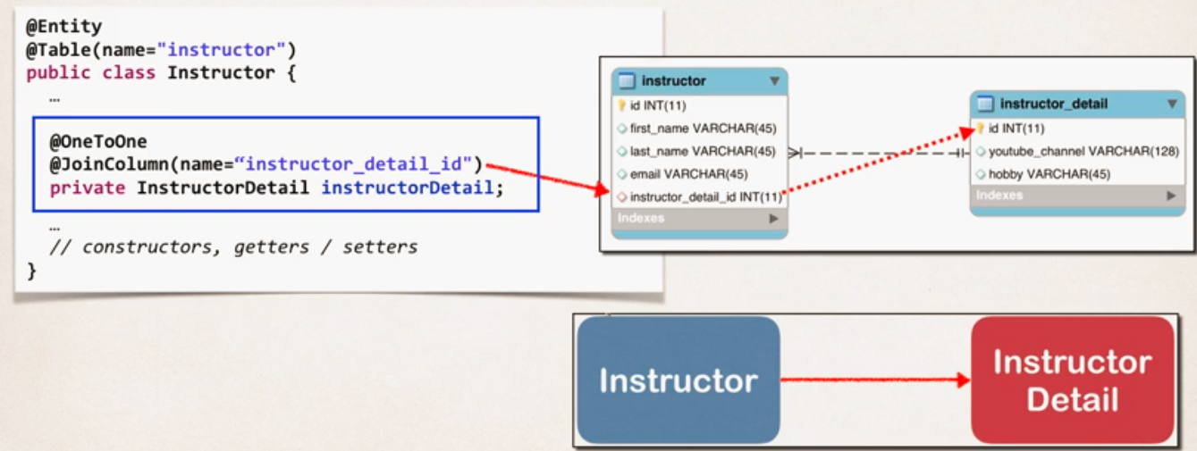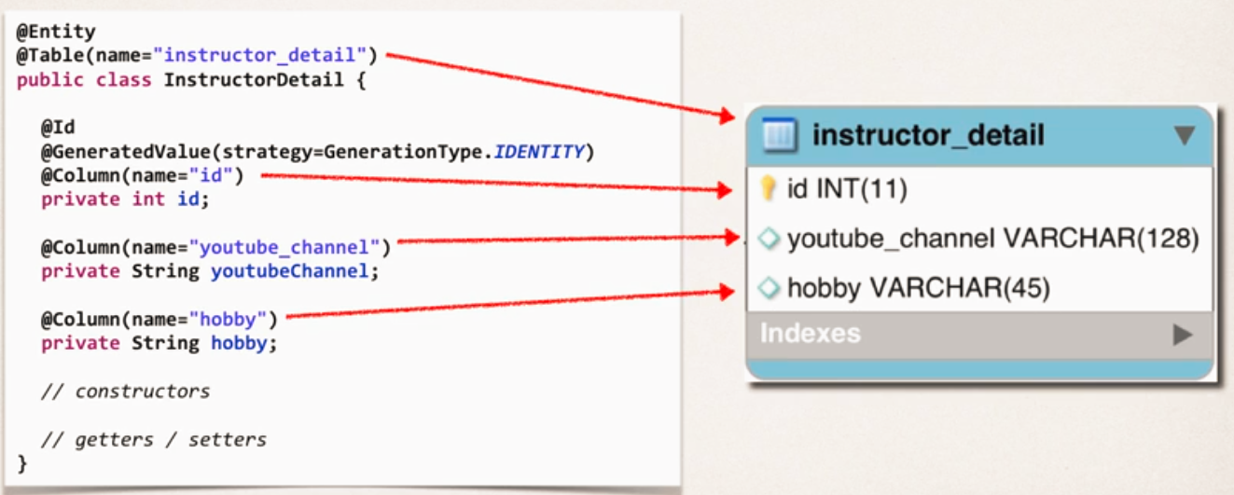

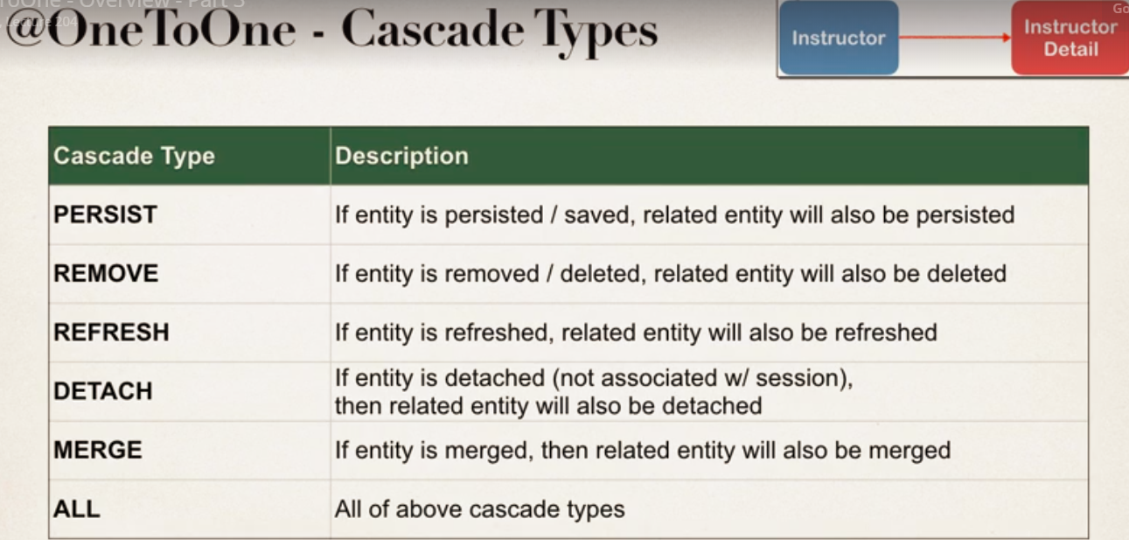

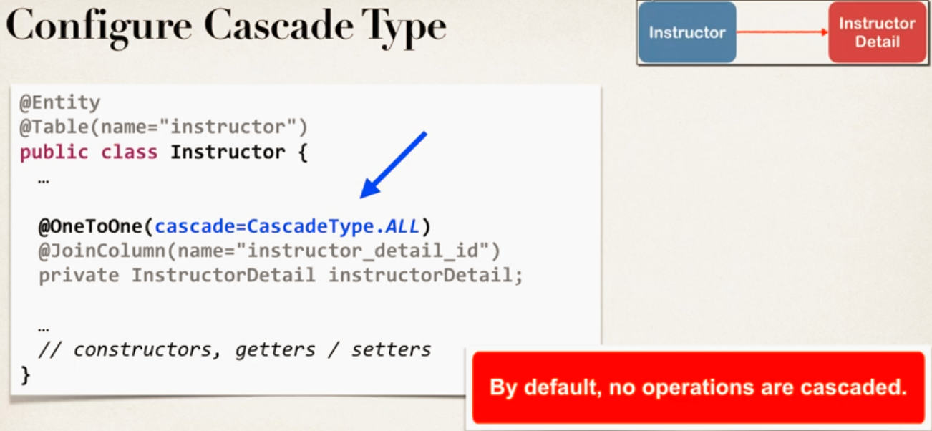

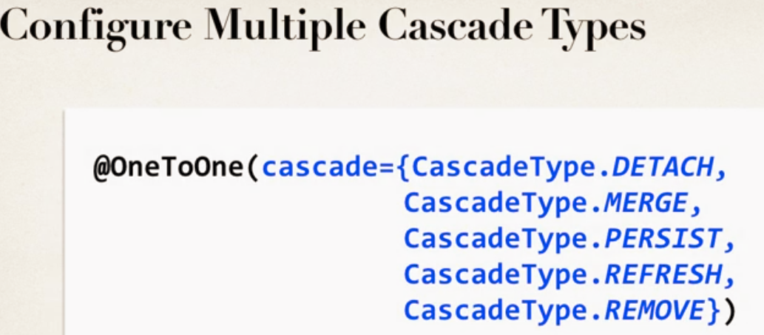

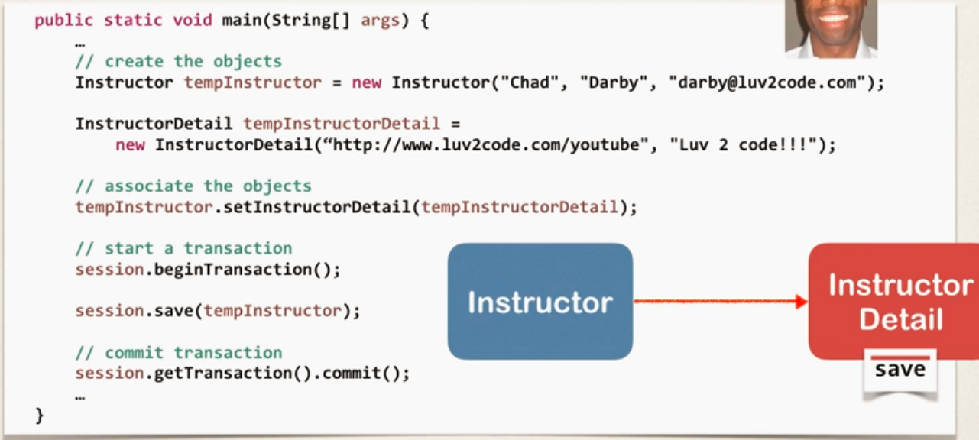

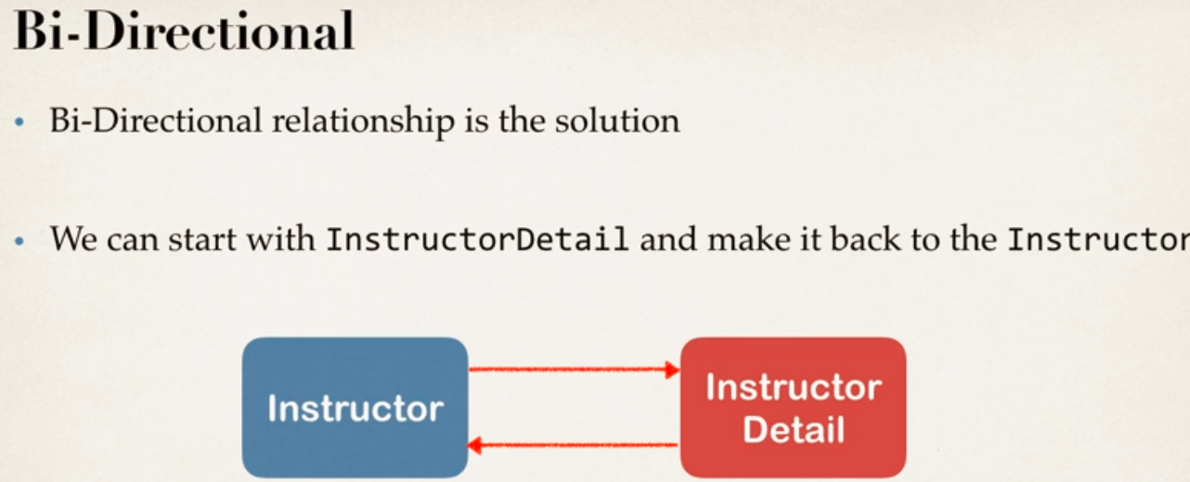

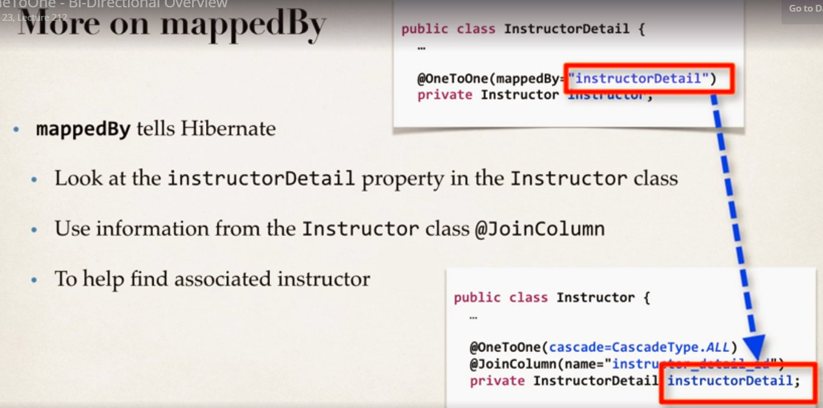

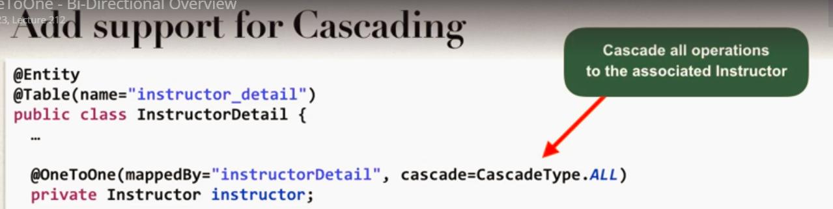

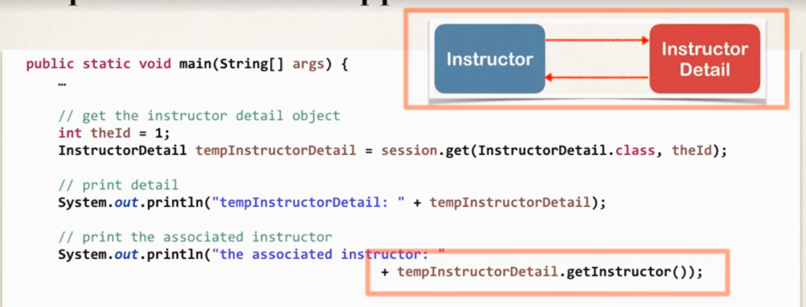

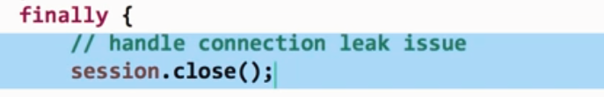

Delete- But don’t want to cascade

Remove cascade type ALL from reference mapping object.

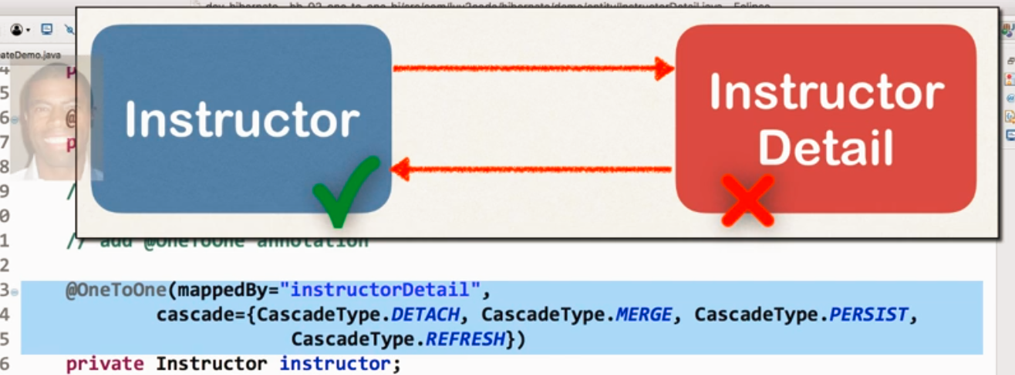

Break bi-directional link i.e. from main instructor object remove reference of instructor details

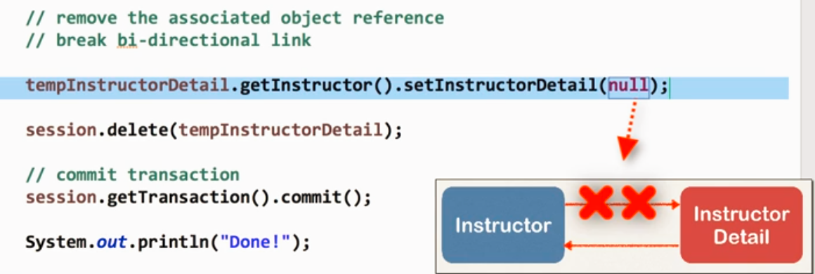

Link in database for instructor details in instructor table is updated to null.

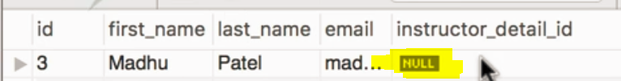

One to Many Mapping Bi Directional

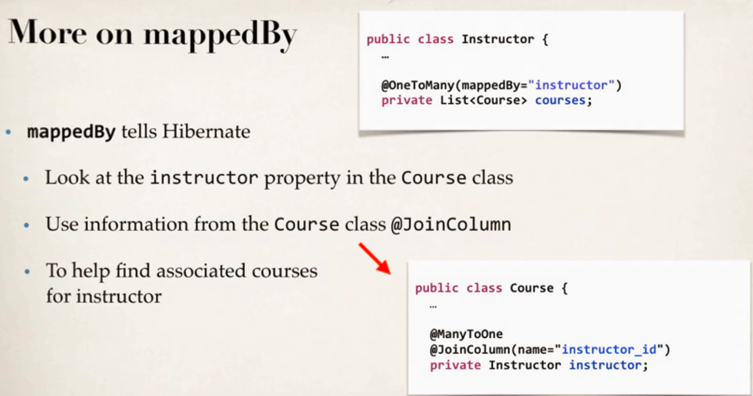MappedBy property means go to annotated used pojo type and look back mapped by value as filed there.

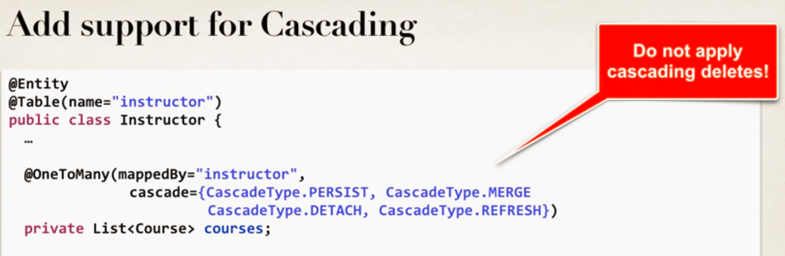JoinColum is used where foreign key is defined on actual database table pojo

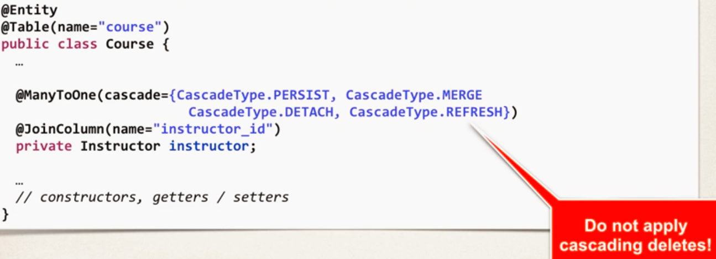

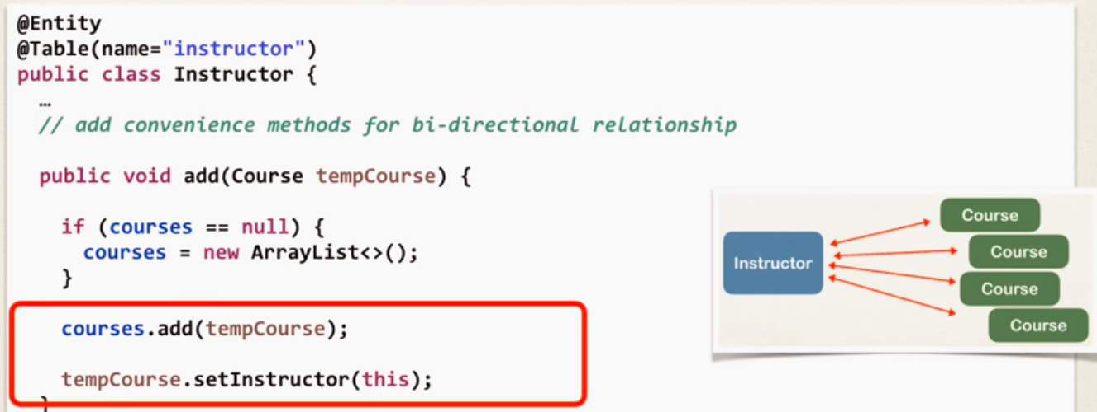

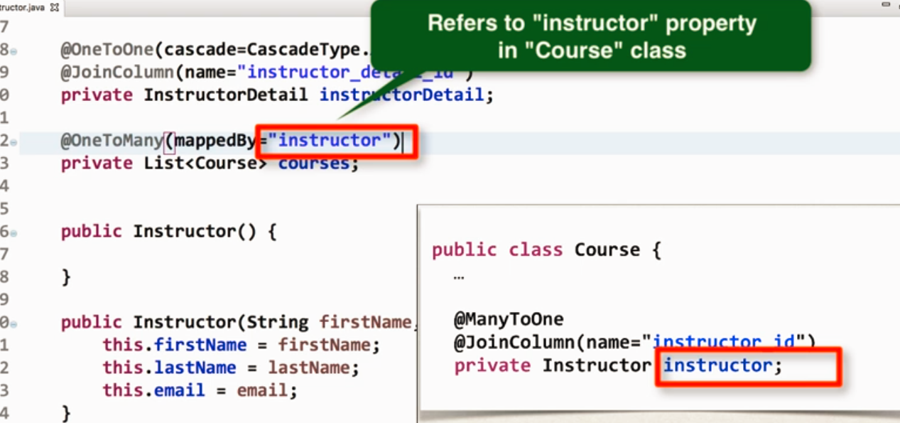

For saving and deleting simply use session object save/delete methods with course object.

Fetch Types – Eager vs Lazy

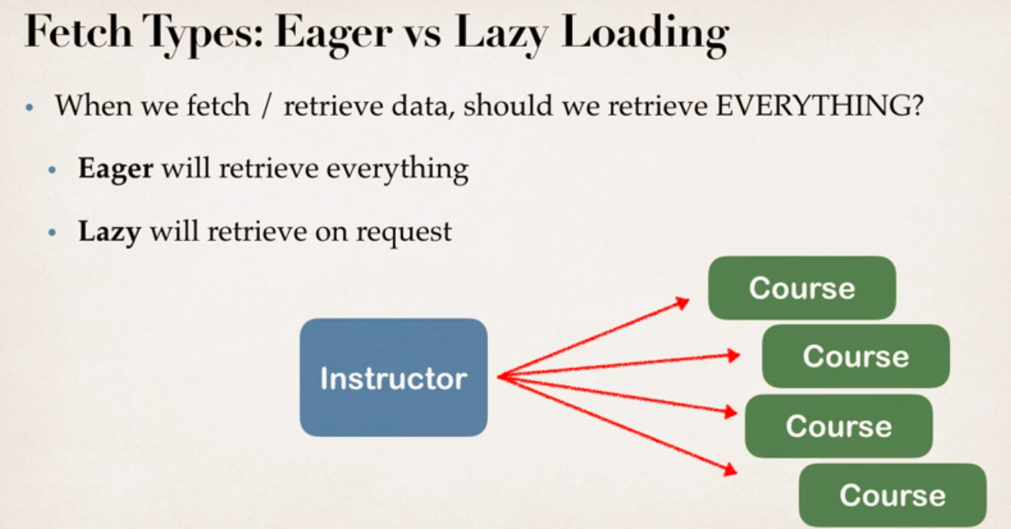

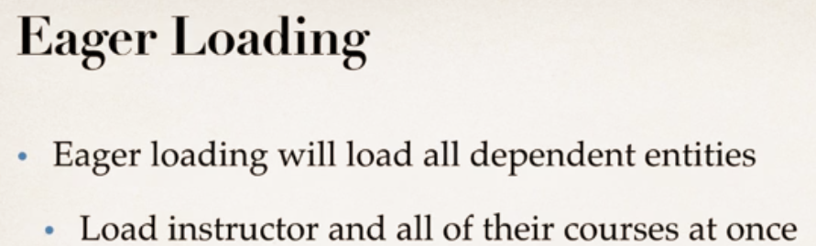

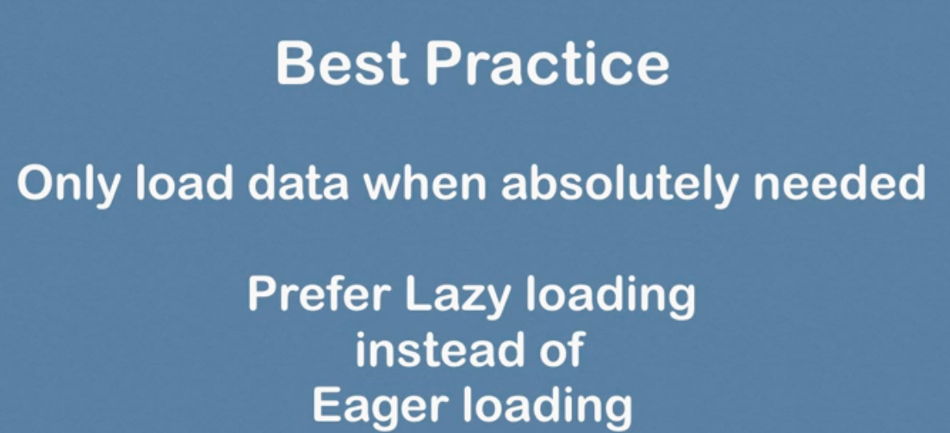

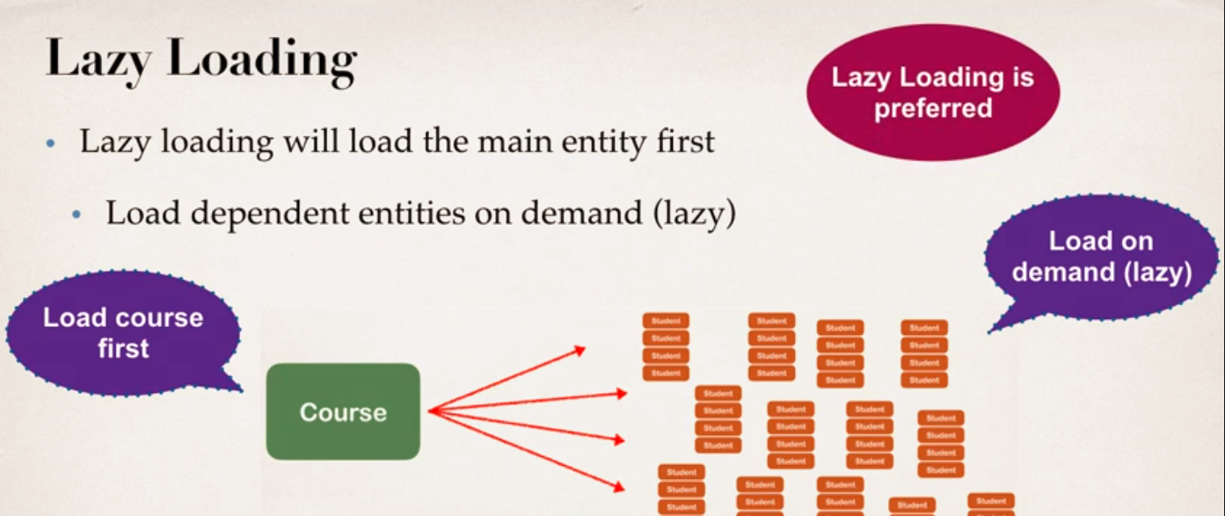

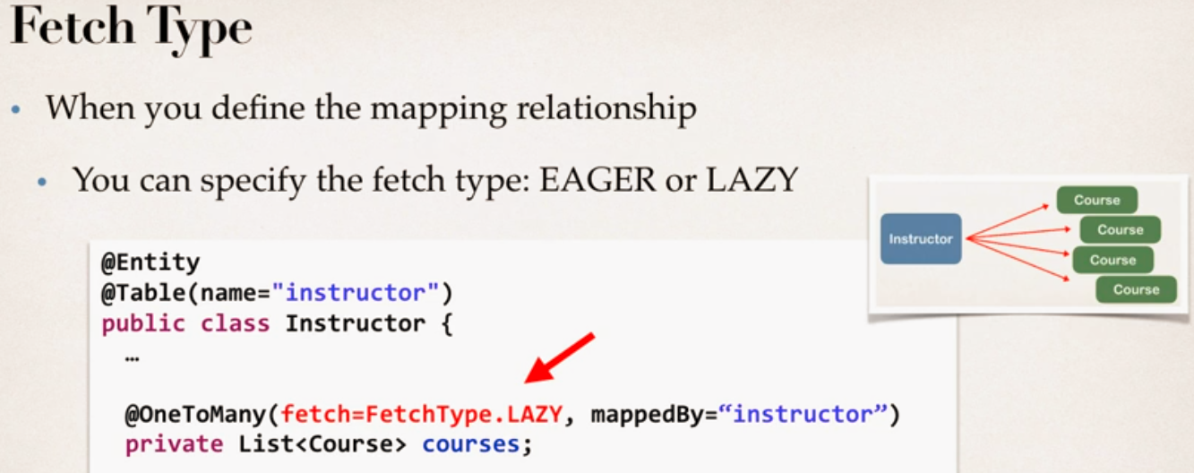

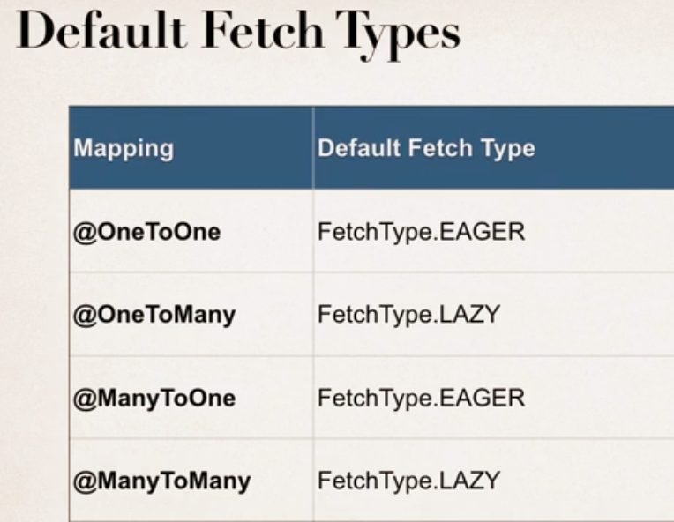

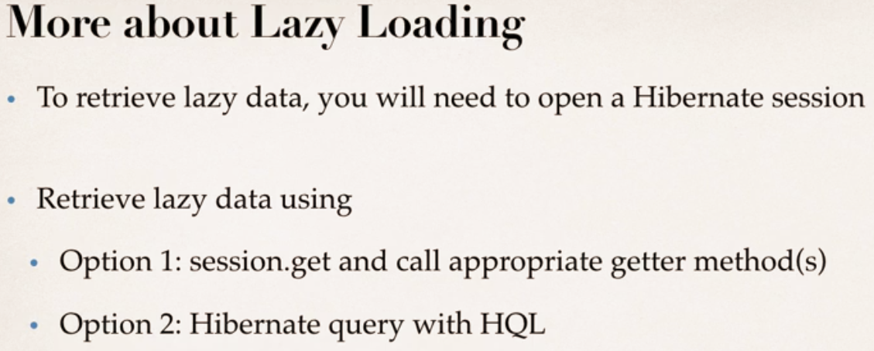

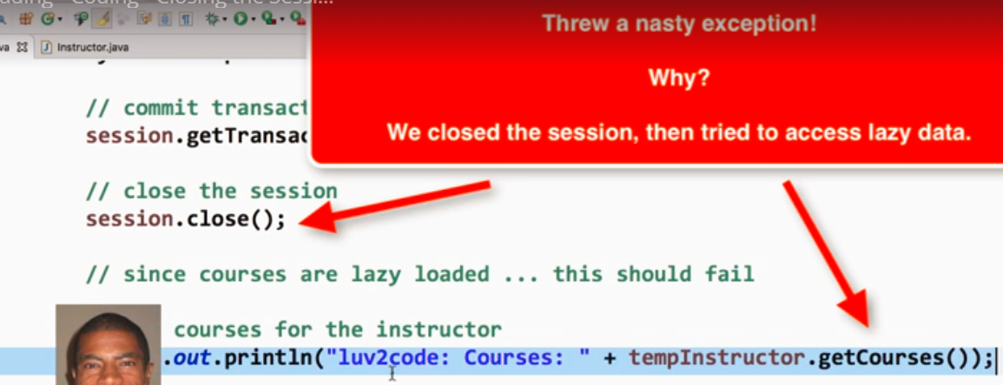

Solution 1: Call getcourse before closing session.

Solution 2: use HQL

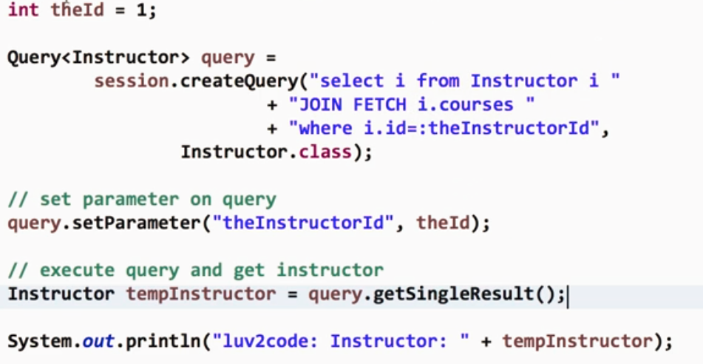

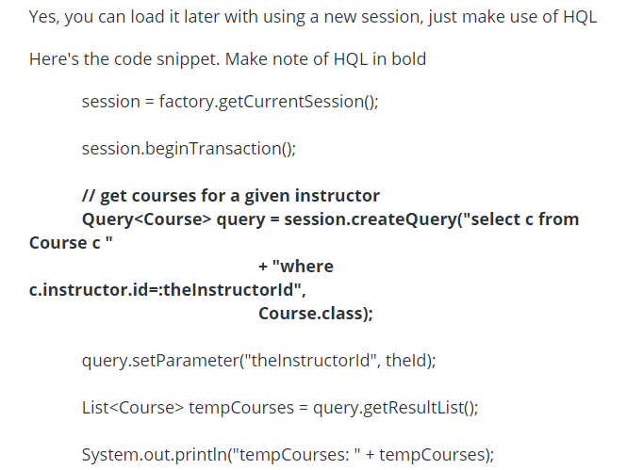

One to Many Uni Directional

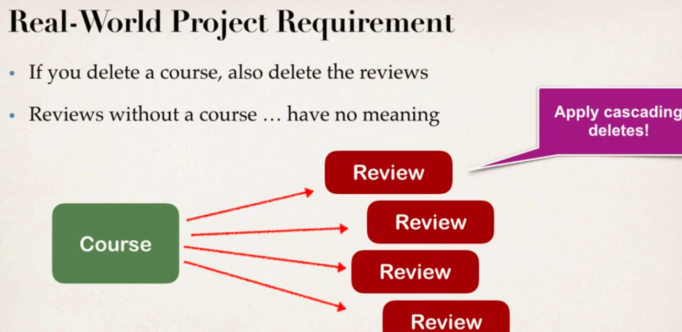

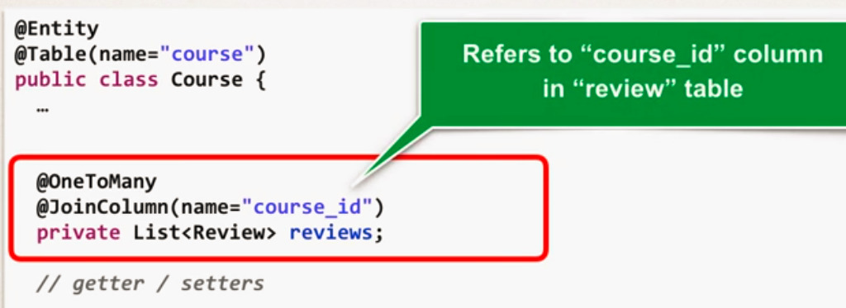

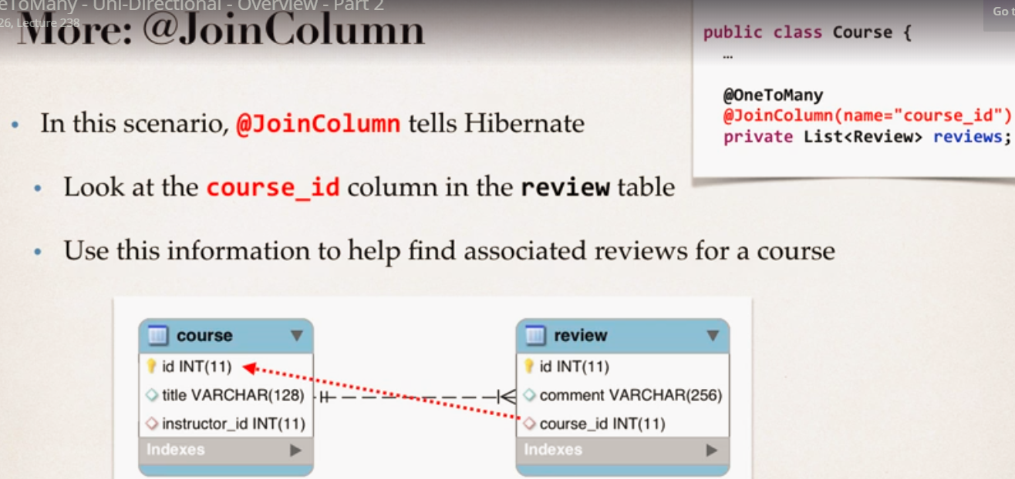

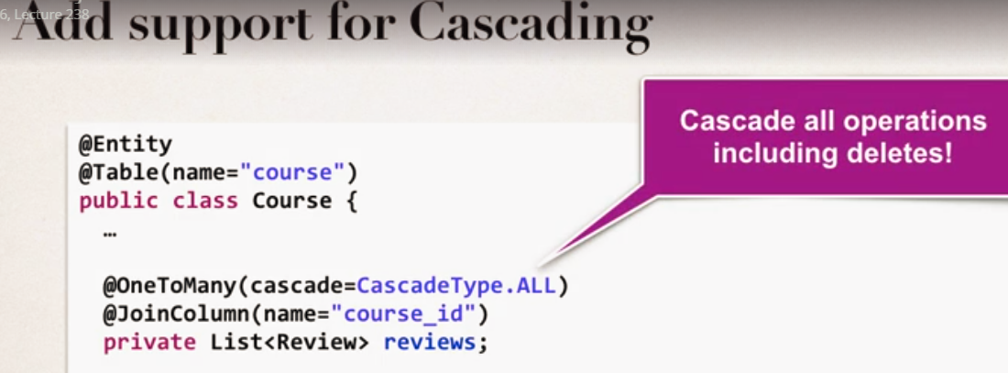

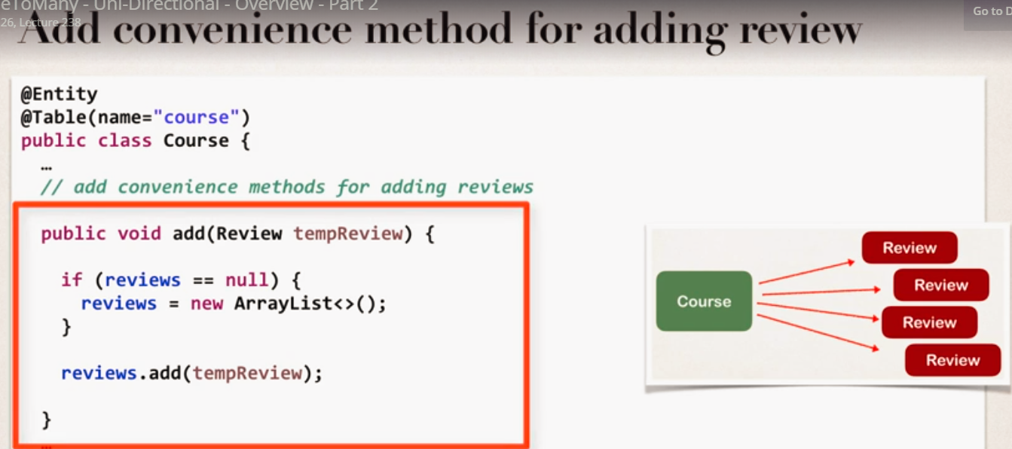

Many to Many Mappings

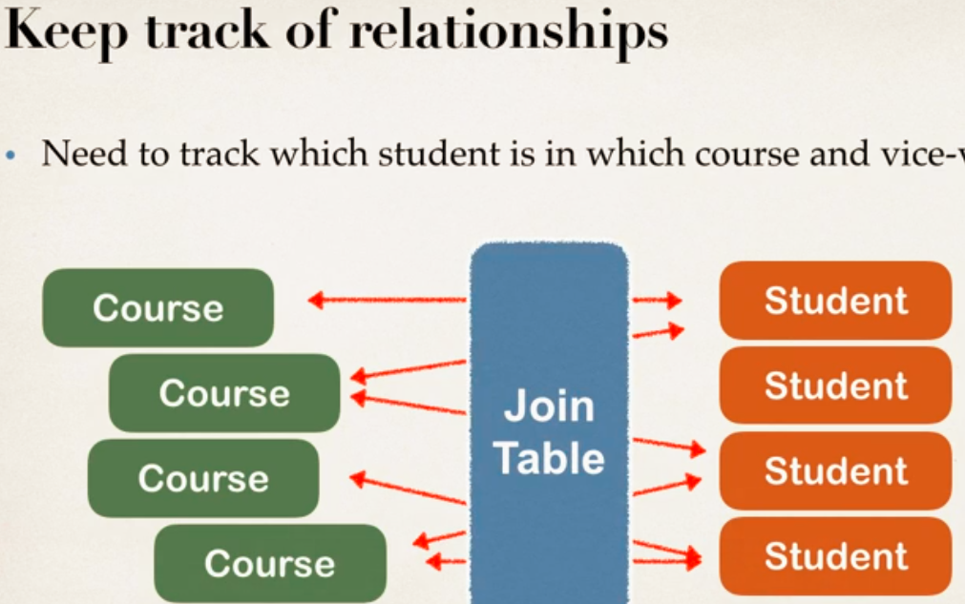

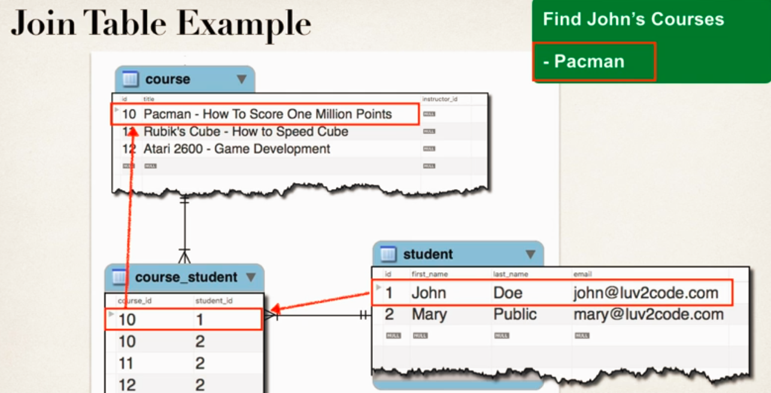

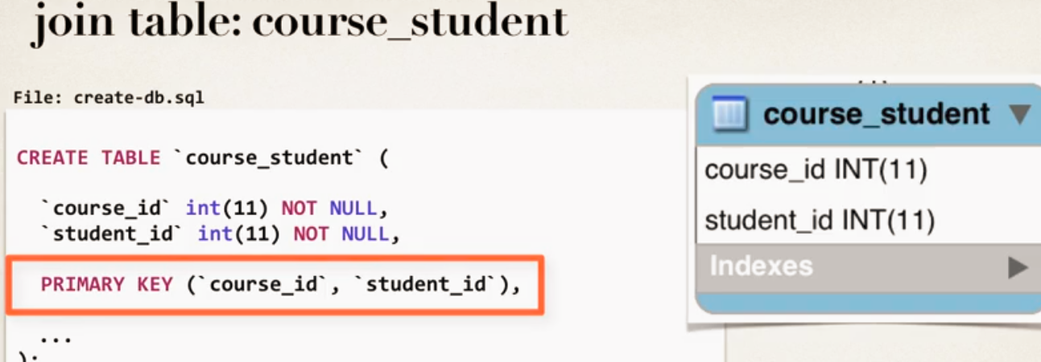

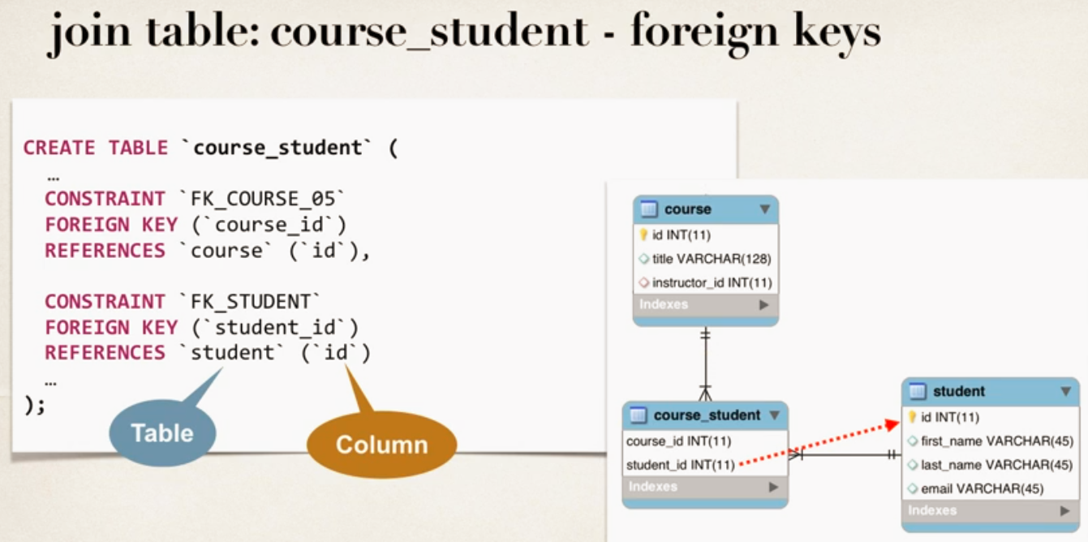

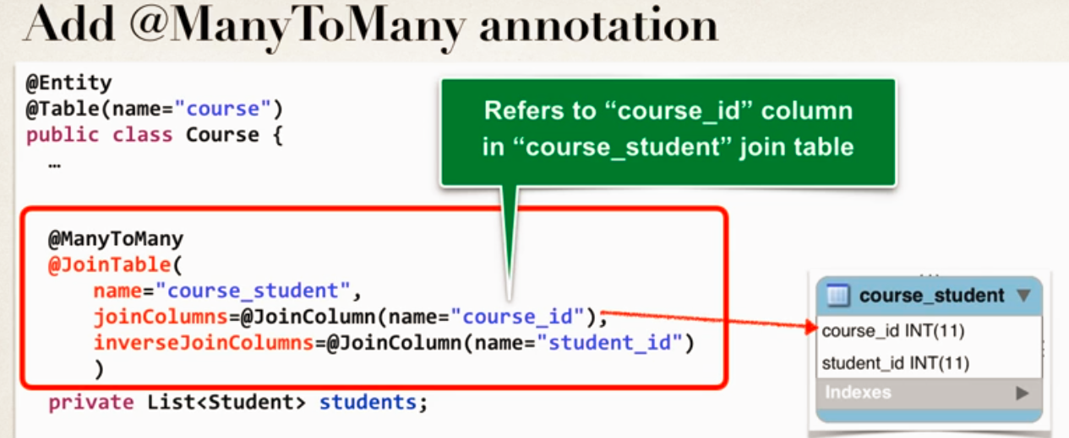

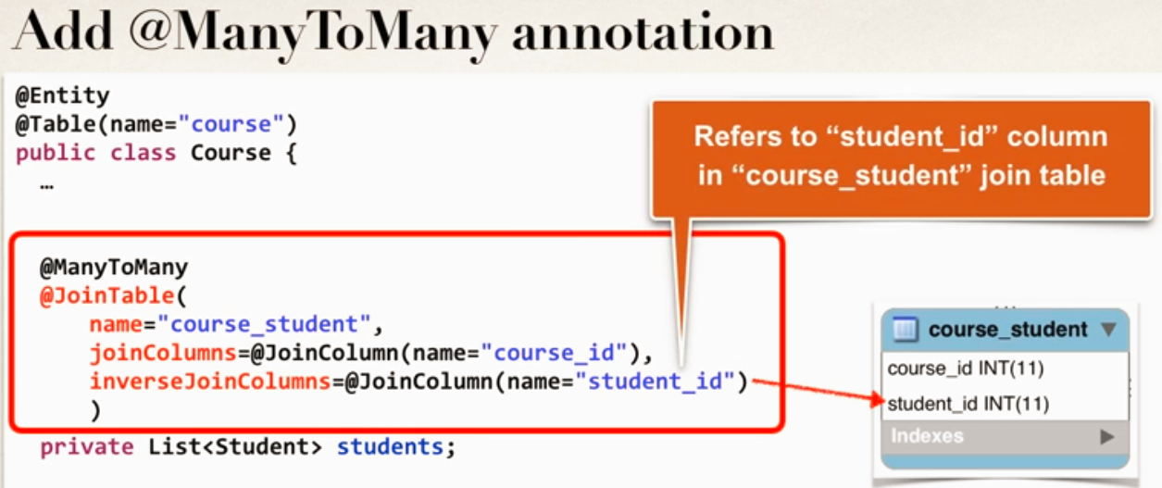

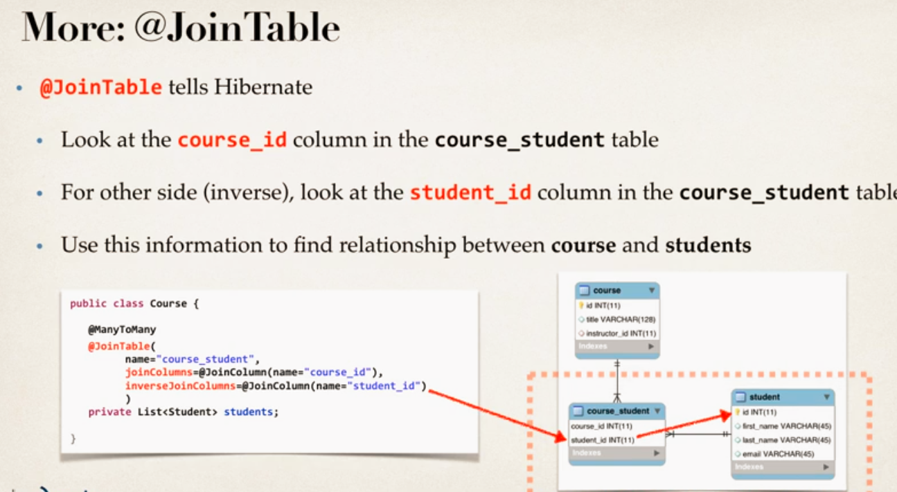

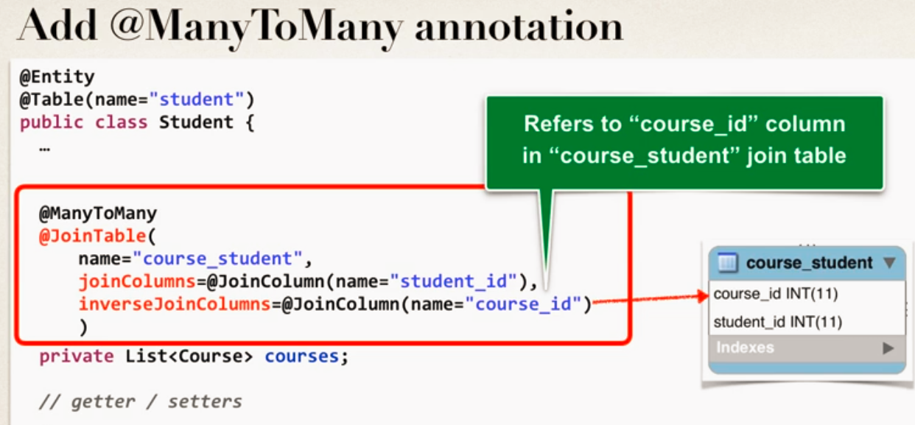

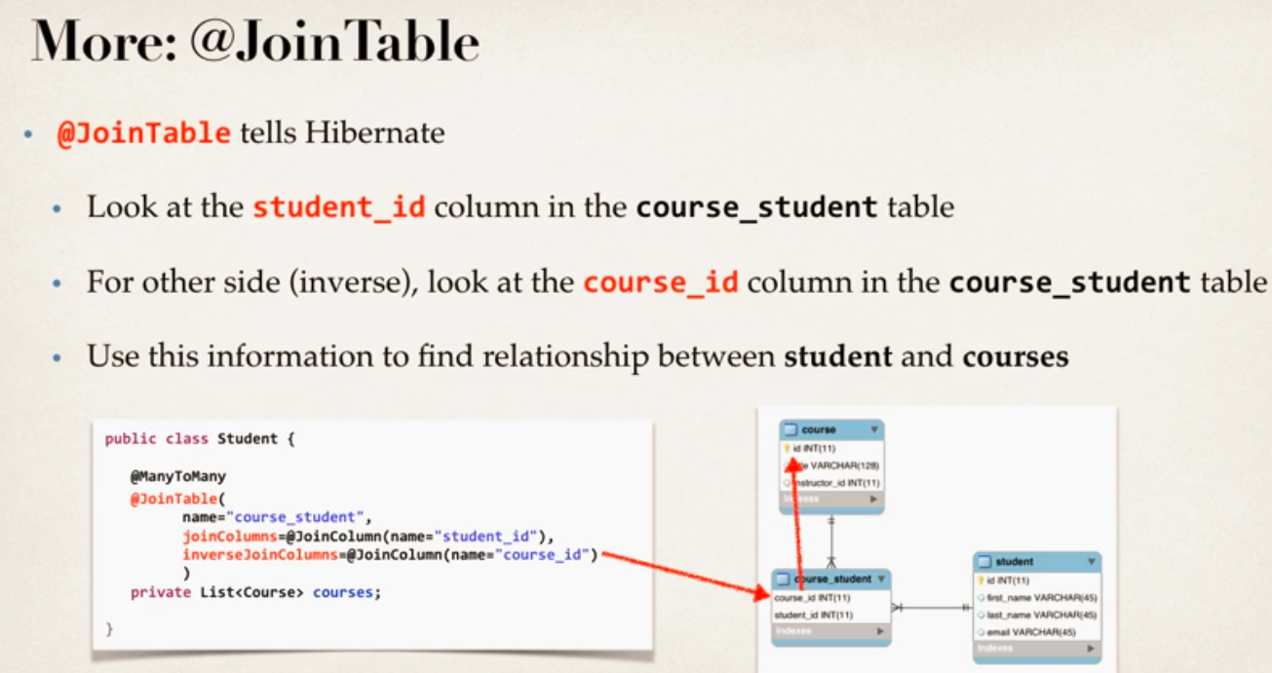

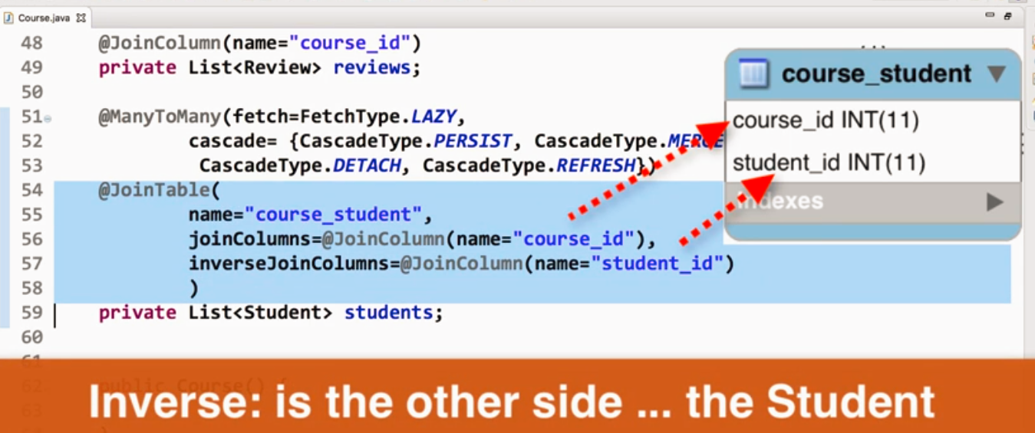

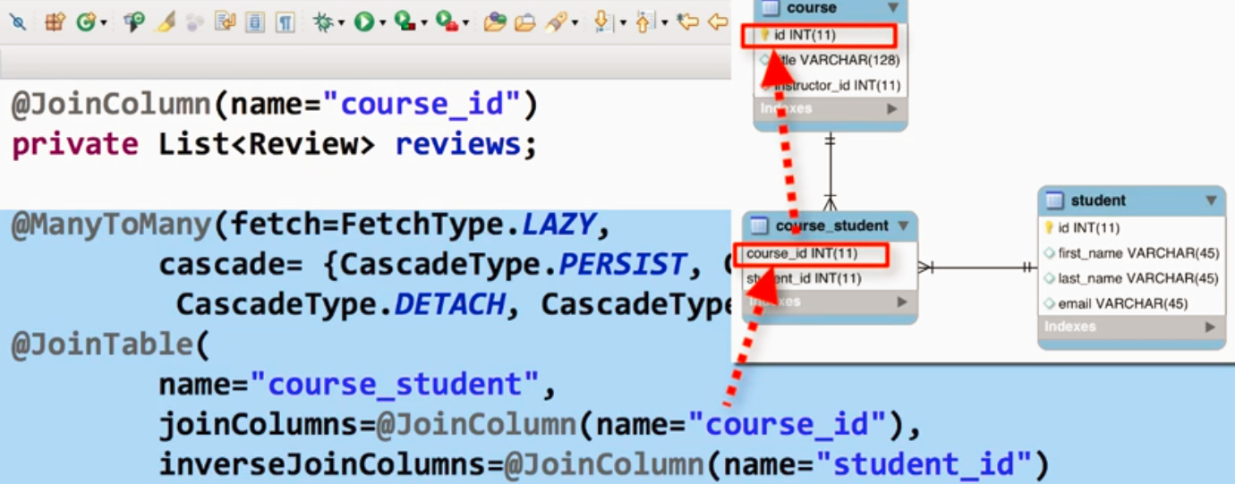

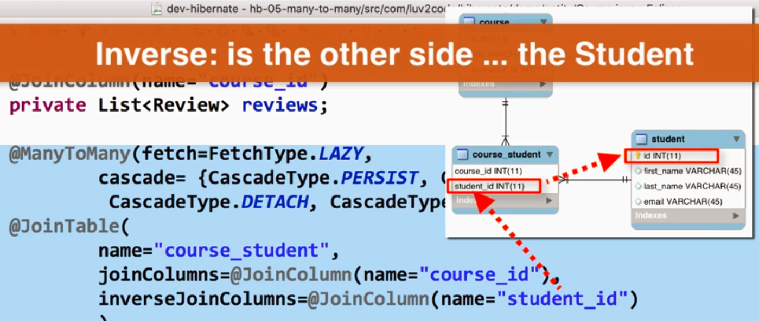

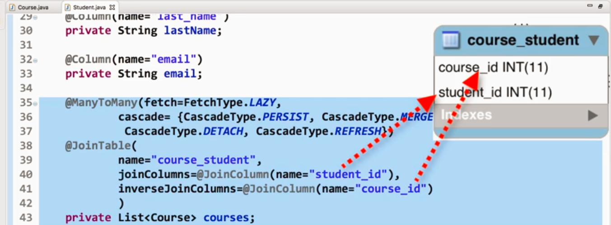Add Course and save course, add students, add them to course and save students.

All relationship will be maintained by hibernate to persist data in relationship table.

Point to note we did not re-saved course after adding students to it through convenience method, only saved students.

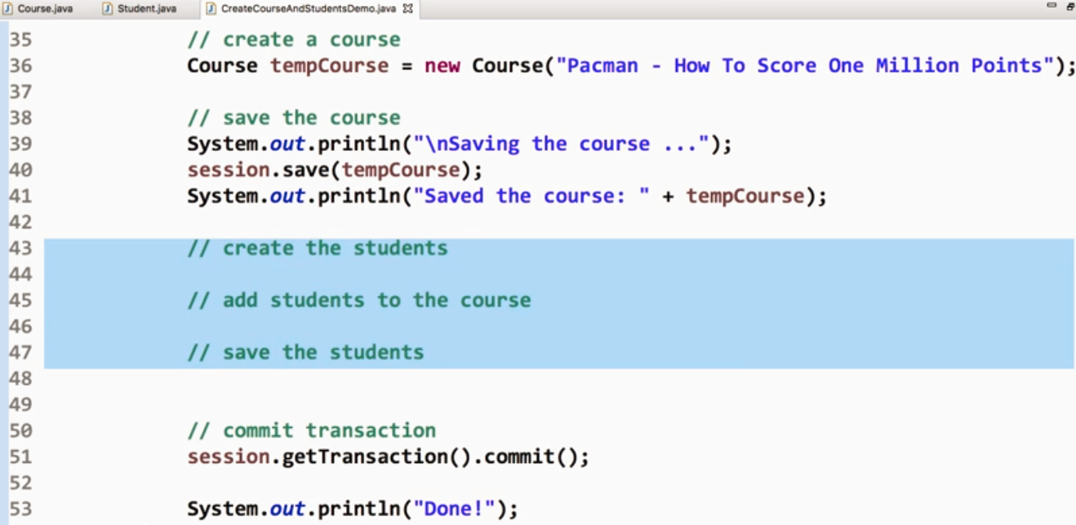

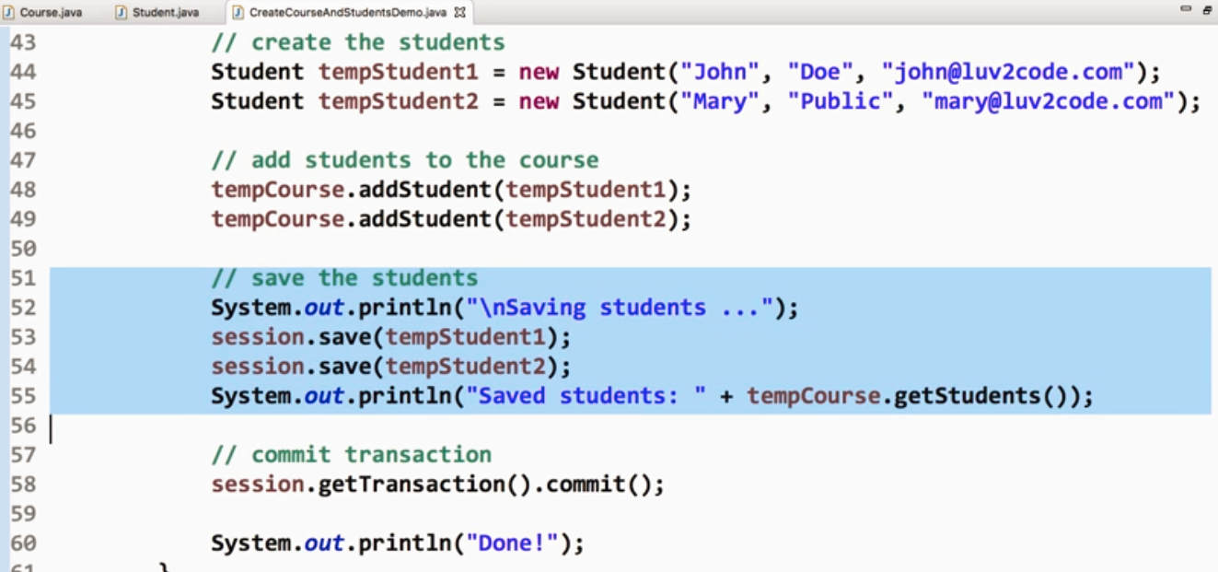

Now add new courses to existing student in database

* Retrieve existing student
* Create new course
* Set student to new course
* Save courses
* Data will be saved for relationship by hibernate

Delete course/student

* This will delete course and clean up relationship table to remove entries for deleted course
* But no student will be deleted.

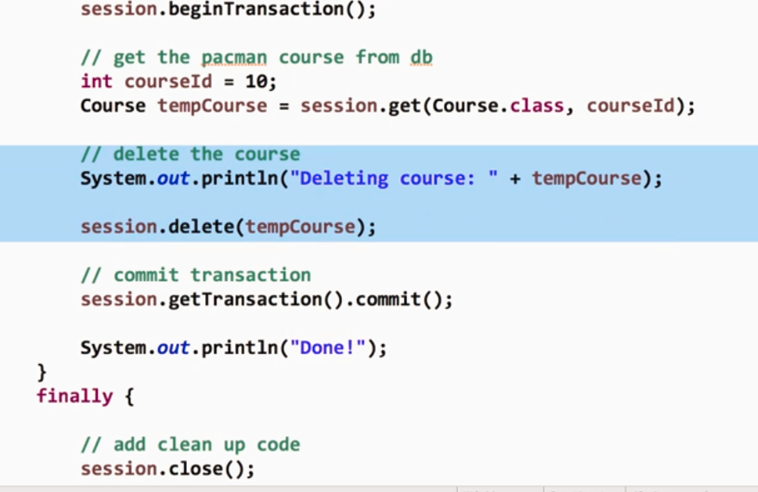

Q&A

**QUESTION:**Why we are using JPA Annotation instead of Hibernate ?

For example, why we are not using this org.hibernate.annotations.Entity?

**ANSWER:**JPA is a standard specification. Hibernate is an implementation of the JPA specification.

Hibernate implements all of the JPA annotations.

The Hibernate team recommends the use of JPA annotations as a best practice.

If you are using Hibernate 5.2 or higher, then the Query list() method has been deprecated.

In your code you should make the following update:

**Replace**

session.createQuery("from Student").list()

**With**

session.createQuery("from Student").getResultList()

FAQ: How To View Hibernate SQL Parameter Values

You can view the actual parameters by viewing the low-level trace of the Hibernate logs. This is not set up by default. However, we can add log4j to allow us to see these low-level logs.

Log4j.properties

log4j.logger.org.hibernate=TRACE

Search for: **binding parameter**

or search for: **extracted value**

**FAQ: Handling Dates with Hibernate**

You can make use of a combination of Java's date formatting class and Hibernate annotations.

We need to add a DateUtils class to handle parsing and formatting dates.

import java.text.ParseException;

import java.text.SimpleDateFormat;

import java.util.Date;

public class DateUtils {

// The date formatter

// - dd: day in month (number)

// - MM: month in year (number)

// - yyyy: year

//

// See this link for details: https://docs.oracle.com/javase/tutorial/i18n/format/simpleDateFormat.html

//

//

private static SimpleDateFormat formatter = new SimpleDateFormat("dd/MM/yyyy");

// read a date string and parse/convert to a date

public static Date parseDate(String dateStr) throws ParseException {

Date theDate = formatter.parse(dateStr);

return theDate;

}

// read a date and format/convert to a string

public static String formatDate(Date theDate) {

String result = null;

if (theDate != null) {

result = formatter.format(theDate);

}

return result;

}

}

we make use of the @Temporal annotation. This is a Java annotation for storing dates.

@Column(name="date_of_birth")

@Temporal(TemporalType.DATE)

private Date dateOfBirth;

set date in pojo

String theDateOfBirthStr = "31/12/1998";

Date theDateOfBirth = DateUtils.parseDate(theDateOfBirthStr);

Student temoStudent = new Student("Paully", "Doe", "paul@luv.com", theDateOfBirth);

**@JoinColum ... where does it find the column?**

**Question**

In the Course class,we have OneToMany relation with reviews with join column course_id.

But in course table we do not have column course_id.

Ideally when we say @JoinColumn a new column should be created in course table ... isn't it?

How does @JoinColum know where to find the join column?

---

**Answer**

The JoinColumn is actually fairly complex and it goes through a number of advanced steps to find the desired column.

This info below is from the documentation

Source: http://docs.oracle.com/javaee/7/api/javax/persistence/JoinColumn.html#name--

---

The table in which it is found depends upon the context.

- If the join is for a OneToOne or ManyToOne mapping using a foreign key mapping strategy, the foreign key column is in the table of the source entity or embeddable.

- If the join is for a unidirectional OneToMany mapping using a foreign key mapping strategy, the foreign key is in the table of the target entity.

- If the join is for a ManyToMany mapping or for a OneToOne or bidirectional ManyToOne/OneToMany mapping using a join table, the foreign key is in a join table.

- If the join is for an element collection, the foreign key is in a collection table.

--

So as you can see, it depends on the context.